

Contents
Why interpreting is a practice responsibility 3
Communication, safety and duty of care 3
When to engage an interpreter 4
Accessing interpreters 4
Languages other than English 4
Patients who are deaf or hard of hearing 5
Billing for consultations involving interpreters 5
Integrating interpreters into your practice 6
Assessing interpreting effectiveness and patient’s understanding 6
Risk of informal interpreters 7
Bilingual staff 7
Family members or friends 7
Artificial intelligence (AI) 8
What if the patient doesn’t want an interpreter? 8
Interpreting is a profession 9
How NAATI certification supports quality and safety 9
NAATI Certification System for Interpreters 9
What to do if the interpreter isn’t certified 10
Quick guide to working with interpreters 11
When should I engage an interpreter? 11
Who can interpret this consultation? 11
How do I access an interpreter? 11
What to do during the consultation 12
Billing interpreted consultations 12

Published September 2026
Every effort has been made to ensure the information contained in this resource is accurate at the time of publication. For the most current version, please visit naati.au/gp.
This publication is the result of a collaborative partnership between The Royal Australian College of General Practitioners (RACGP) and the National Accreditation Authority for Translators and Interpreters (NAATI).

Why interpreting is a practice responsibility

Communication, safety and duty of care
Clear and effective communication is the foundation of all high-quality clinical care. Clinicians have a responsibility to support clear, safe and effective communication as part of patient-centred quality care provision and clinical governance.

In Australia, one in five people (22%) speak a language other than English at home, and around 700,000 people aged over five have limited or no English proficiency. Language barriers can affect patient safety and are considered a clinical risk. The RACGP Standards expect practices to identify these risks and have processes in place to manage them across the practice team.

Language barriers are associated with:
- increased medico-legal risk
- diagnostic errors and adverse outcomes
- lack of informed decision-making and informed consent
- poor understanding of and adherence to clinical instructions
- unnecessary consultations and referrals
- less patient satisfaction and disengagement from care
- higher risk of complaints
- staff placed in ethically, professionally and legally challenging situations.

In this context, when a patient and clinician do not share a common language, professional interpreters play a critical role in ensuring safe communication and reducing risk. Professional interpreters help make healthcare safer and more inclusive. They function as part of the care team and are there to support both the patient and the clinician. They support clear, accurate and confidential communication between patients and health professionals, so everyone can understand and be understood.

In Australia, professional interpreters are generally certified by NAATI, the National Accreditation Authority for Translators and Interpreters. More on NAATI certification on page 9.

Professional interpreting is not an optional add-on if you face a language barrier when communicating with a patient. Under National Safety and Quality Health Service Standards (Action 2.08), health services are required to ensure certified interpreter services are available to consumers who need them.

RACGP
Standards
General practices must provide patients with information and recommendations about the care they receive in a format and language they understand. Section 3.2d of the Australian Health Practitioner Regulation Agency’s Shared Code of Conduct requires practitioners to “take all practical steps to meet the specific language, cultural, and communication needs of patients and their families, including by using translating and interpreting services where necessary”.

When to engage an interpreter
A GP should not assume a patient does not need an interpreter based solely on the patient’s ability to hold a general conversation. Medical conversations often need to convey specific, complex information that must be strictly adhered to and require a sophisticated understanding of language to be properly understood.

Also, the need for an interpreter may change during a consultation. This can become evident as discussions become more complex or emotionally sensitive. GPs should be prepared to pause the consultation and engage an interpreter at any point during the consultation process.

Indicators that an interpreter is required:

- the patient requests an interpreter
- the patient has limited capacity to grasp or respond to questions in the language you speak or responds in a limited way
- the patient speaks English as a second language, and it is a complex or stressful situation
- the patient indicates that they want family or friends to interpret
- the patient is using a translating app such as Google Translate
- the patient is deaf or hard of hearing, requiring an Auslan interpreter
- you believe you require one to exercise your professional duty of care towards a patient.

This is particularly important when:
- complex information is being discussed, you are making a diagnosis, or you are asking for consent
- you need to discuss sensitive topics with the patient such as sexual or mental health, domestic violence or culturally sensitive topics
- misunderstood or miscommunicated information could result in patient harm.

Accessing interpreters

Languages other than English
Practices can engage interpreters through language service providers that may be publicly or privately operated. Interpreter services are available by phone, video or onsite, depending on the needs of you and your patient.

Eligible GPs and practice staff working in private practice can use the Australian Government-funded Free Interpreting Service.
FIS (Free Interpreting Service)
The Free Interpreting Service can provide immediate phone interpreting services via a 24-hour medical practitioner priority line 1300 131 450, or pre-booked phone, video and in-person interpreting services. Generally, these interpreters will be NAATI-certified.

Check your eligibility: https://bit.ly/FIS-eligibility
If you or your clinic is not eligible to access free interpreting services, you can set up an interpreting arrangement with another language service provider. A list of NAATI-endorsed language service providers that provide access to NAATI-certified interpreters is available on the NAATI website: https://directory.naati.com.au/.

Always check the preferred gender and dialect of the interpreter with the client, explaining that sometimes the preferred gender may not be available.

Patients who are deaf or hard of hearing
Communicating with people who are deaf or hard of hearing can be supported through sign language interpreters either in person or via video conference. Sign language interpreters can be requested via a language service provider.

Note that the Australian Government-funded Free Interpreting Service does not provide Auslan interpreting services.
If you need to communicate with someone who is deaf or hard of hearing over the phone, you can contact the National Relay Service (NRS). For more information, visit https://bit.ly/nrs-help

Billing for consultations involving interpreters
While interpreted consultations are longer, they will:
- save time through less repeat visits and unnecessary referrals
- improve diagnostic accuracy
- lower medico-legal risk
- support informed consent and shared decision-making
- reduce misunderstandings.

When claiming for time-tiered MBS items, the total duration includes the time required to communicate effectively with the patient. This includes the time required to work with an interpreter if your patient doesn’t share your language or is deaf or hard of hearing. When working with an interpreter, it is considered reasonable to claim a longer attendance item than might otherwise be expected for the service. This applies to both face-to-face and telehealth services.

In such situations, medical practitioners and other providers should record in the consultation notes why the additional time was required. For example, ‘consultation extended due to interpreter engagement’, and if relevant citing the TIS or other language service provider job number.

Some examples of MBS items for longer consultations that may be required when working with interpreters are outlined below.

MBS item | Item description
36 | Level C standard consultation 20–40 minutes
44 | Level D standard consultation 40–60 minutes
123 | Level E standard consultation 60+ minutes
91801 | Videoconference level C standard consultation 20–40 minutes
91802 | Videoconference level D standard consultation 40–60 minutes
91920 | Videoconference level E standard consultation 60+ minutes
91900 | Telephone level C standard consultation 20–40 minutes (MyMedicare patients only)
91910 | Telephone level D standard consultation 40–60 minutes (MyMedicare patients only)
In June 2022, the Department of Health and Aged Care published a fact sheet which provides information on how to account for time taken to communicate with patients when claiming time-tiered MBS items: https://bit.ly/mbs-inclusion-times
Enquiries regarding billing rules and MBS item interpretation should be directed to askmbs@health.gov.au

Integrating interpreters into your practice
There are simple steps practices can take to incorporate working with interpreters into the workflow.

These include:
- recording patients’ preferred language and interpreter need in their medical record, including any interpreter gender or dialect preferences
- identifying interpreter needs at time of booking the appointment so an interpreter can be pre-booked
- making sure all relevant staff are set up with a TIS National client code (if eligible for the Free Interpreting Service) or other language service provider arrangement
- training reception and clinical staff in how to recognise the need for an interpreter and how to engage one
- displaying signage indicating interpreters are available for patients
- documenting interpreter engagement in the clinical record, including whether they are NAATI-certified
- identifying patient interpreter needs in referrals
- providing feedback to the language service provider about quality and certification status.

You can refer to NAATI’s resource on how to work with interpreters here: https://naati.au/medical-interpreting
Further information about integrating interpreters into your practice can be found in the Guide for Clinicians Working with Interpreters in Healthcare Settings: https://bit.ly/guide-for-clinicians-interpreting

Assessing interpreting effectiveness and patient’s understanding

If you suspect an interpreter is not interpreting accurately or your patient seems uncomfortable, engage a new interpreter or reschedule the appointment with a different pre-booked interpreter. New interpreters can be engaged fairly quickly through the Free Interpreting Service.

Remember to frequently check your patient’s understanding using techniques such as the “teach back method” and assess your patient’s level of comfort or distress with the interpreting.

You can make a complaint about an interpreter’s conduct to the language service provider that they work for, or to NAATI.

Risk of informal interpreters
GPs operate in a fluid environment where quick communication can be essential. However, having a child, family member, an untrained bilingual staff member or AI tool interpret medical conversations poses significant risks to patients including risks to privacy, consent and safety for the patient and medico-legal risk for the GP.

When faced with a language barrier clinicians should assess the following:
- clinical risk factors, such as consequences of miscommunication, complexity of decision-making, potential for medication error or delayed diagnosis
- patient factors, such as English proficiency, health literacy, cognitive state, which language/s they speak, and support people available.
- system factors, such as interpreter availability, urgency, and organisational policy.

When in doubt, GPs should engage a professional interpreter to help mitigate medico-legal risks around duty of care. Once a practice is set up with the Australian Government’s Free Interpreting Service or a private language service provider, accessing interpreters is quick and convenient.

If a GP does not work with an interpreter when there is a language barrier present, then it is important for them to document the reason for not working with an interpreter within the medical record e.g. provide verifiable documentation on the attempts to access an interpreter that were not successful.

Bilingual staff
Bilingual staff can make a real difference in making patients feel welcome at a practice and are able to provide education and guidance about the cultural context patients may live in. However, bilingual staff (other than clinicians) should only be asked to interpret in non-clinical situations such as making appointments. While bilingual staff can offer patients confidentiality and impartiality, their bilingual skills may not be sufficient for high-risk consultations. When it comes to consultations exploring diagnoses and treatments, seeking consent or circumstances where misunderstanding could cause harm, a professional interpreter should be called.

NAATI offers free online training about bilingual workers (also known as community language aides) and how to assess the need for an interpreter. You can access it at https://naati.au/cla-course

Family members or friends
GPs should also be aware of the risks associated with asking a family member or friend to interpret as this can affect accuracy and limit patient choice.

Untrained family members and friends:
- will be unlikely to understand the medical terminology or be able to interpret it effectively
- may filter, change or withhold information due to cultural roles, power dynamics, or a desire to protect the patient
- may not treat the information discussed as confidential
- may be traumatised or experience stress due to interpreting.

Patients may be unwilling to disclose pertinent information, particularly about sensitive issues such as mental health, sexual health or domestic violence in front of family members, especially in the context of past trauma.

Children and young people under the age of 18 should never be asked to act as interpreters.

Artificial intelligence (AI)
AI translation and interpreting can only be used for low-risk, non-clinical communications, such as when delivering appointment reminders, helping patients to book appointments or patient wayfinding.

While AI can be very fast and accessible, clinicians need to be aware of the risks associated with its use. AI is known to struggle with medical terms and can misinterpret nuance and tone (i.e. minimising or reversing the difference between “possible” and “likely”). AI also struggles to understand culturally specific information or context (such as the urgency of the appointment).

Where miscommunication could result in harm to a patient, AI should never be used.

What if the patient doesn’t want an interpreter?
Patients may express a preference for informal interpreters due to familiarity, perceived privacy or trust. In these situations, practices should consider whether communication remains accurate, confidential and appropriate for clinical decision-making.
If a patient declines the service of a professional interpreter, the GP or clinic staff should explore and address the patient’s concerns before deciding to proceed without one. The patient may have misconceptions about interpreter confidentiality and impartiality (see Interpreting as a profession on page 10), cost (they may be free), or have unspoken preferences such as interpreter gender (this could be arranged).
Supporting patient choice while maintaining safe communication is an important component of good clinical practice. For example, the patient may be happy to engage with a professional interpreter if a family member can also be present in the room for support, with the patient’s consent. If confidentiality is a concern for the patient, a phone interpreter could be engaged and the patient’s name does not need to be given to the interpreter.
The choice to proceed without an interpreter needs to be recorded in the patient’s clinical record.
RACGP
Standards
The RACGP Standards and NAATI advise against asking family members or friends to interpret, except where specifically requested and appropriate. Risks include inaccurate translation, emotional burden and breaches of confidentiality — particularly when children are involved.

Interpreting is a profession

How NAATI certification supports quality and safety
NAATI (the National Accreditation Authority for Translators and Interpreters) is Australia’s national standards and certification body for translators and interpreters. NAATI certifies people who choose to work as professional interpreters in Australia and New Zealand.

NAATI-certified interpreters:
- have formal training in interpreting.
- demonstrate assessed language proficiency.
- demonstrate the ability to work cross-culturally.
- engage in continuous professional development.
- operate under a nationally recognised code of ethics, including:
- accuracy
- impartiality
- confidentiality
- professional accountability

NAATI Certification System for Interpreters
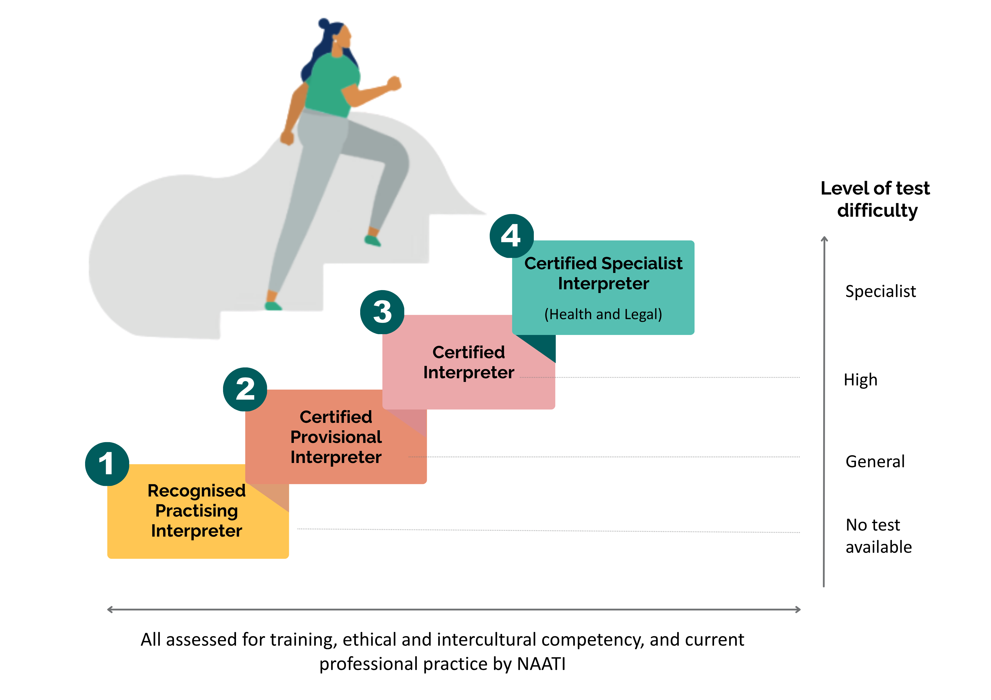

There are different NAATI credentials for different interpreting skill sets and languages. The Free Interpreting Service or other language service providers will provide the most appropriate interpreter available. For most patient consultations, a Certified Provisional Interpreter will be sufficient.

For more information on NAATI certification view: https://www.naati.com.au/certification/.

What to do if the interpreter isn’t certified
While most interpreters working at the Free Interpreting Service or a private language service provider will be NAATI-certified, this may not always be the case. NAATI certification is a mark of quality assurance. You can check if an interpreter is certified by asking for their CPN (Certified Practitioner Number) and verifying it on NAATI’s website: http://naati.au/verify

If someone is not certified, they may still be a good interpreter – it just means they haven’t had their skills assessed by an independent body. This is often the case with emerging languages in Australia.

To better understand their abilities, you can:
- ask if they have been trained as an interpreter
- ask about the interpreting experience they have
- record in your notes that the interpreter is not certified
- continue with the appointment as planned or reschedule if you are concerned
- ensure you understand their relationship with the patient.

RACGP
Standards
Engaging an interpreter is not just good practice; it is part of practice responsibility. The RACGP Standards Criterion 1.4 says practices should endeavour to engage an interpreter whenever patients do not speak the primary language of the practice team, document interpreter engagement in the health record, and make translated or plain-English resources available where possible.

Quick guide to working with interpreters

When should I engage an interpreter?
- the patient requests an interpreter
- the patient has limited capacity to grasp or respond to questions in the language you speak or responds in a limited way
- the patient speaks English as a second language, and it is a complex or stressful situation
- the patient indicates that they want family or friends to interpret
- the patient is using a translating app such as Google Translate
- the patient is deaf or hard of hearing, requiring an Auslan interpreter
- you believe you require one to exercise your professional duty of care towards a patient.

Who can interpret this consultation?
 | Low risk,  such as appointment scheduling | Consultation about sensitive subjects (sexual health, mental health, domestic violence) | Could misunderstanding result in patient harm? | Providing a diagnosis | Receiving  consent
Professional interpreter | Yes | Yes | Yes | Yes | Yes
Bilingual staff (other than clinicians) | Maybe | Not recommended
Bilingual person | Maybe
AI tools | Maybe

It’s your responsibility as a GP to ensure an interpreter is engaged if you and the patient can’t understand each other well due to a language barrier. If in doubt, engage a professional interpreter.

How do I access an interpreter?
- Check your eligibility for the Australian Government-funded Free Interpreting Service available to eligible GPs and practice staff working in private practice: https://bit.ly/FIS-eligibility
- If you or your clinic is not eligible for free interpreting services, you can contact another language service provider to set up an interpreting arrangement. A list of NAATI-endorsed language service providers is available on the NAATI website: www.naati.com.au
- Contact the National Relay Service (NRS) to communicate with patients who are deaf or hard of hearing. Visit https://bit.ly/nrs-help

What to do during the consultation
- If possible, provide the interpreter with a brief on what will be discussed, including if the content will be emotional, technical or sensitive.
- Introduce the interpreter to the patient and explain their role to the patient.
- Ensure your patient understands that the interpreter is obliged to keep the consultation private.
- Speak directly to the patient rather than to the interpreter. For example, say “are you having any chest pain?” instead of “ask her if she’s having any chest pain”. Maintain eye contact with the patient rather than the interpreter.
- Use clear, simple language and pause regularly to give the interpreter time to interpret.
- Clarify as needed. If something seems unclear for either you or your patient, ask the interpreter to repeat or explain. Encourage the interpreter to speak up if they need something clarified. If the interpreter needs clarification, ask them to inform the other person what they are asking.
- Debrief with the interpreter, if necessary, especially if it has been an emotional or distressing topic. This allows you to check on their wellbeing and also to receive feedback. It is possible that the interpreter could have a background history of trauma in the past and sensitive issues can be unexpectedly triggering. Interpreters have access to a mental health support line from NAATI if needed.

Billing interpreted consultations
When claiming for time-tiered MBS items, the total duration includes the time required to communicate effectively with the patient. This includes the time required to work with an interpreter. Some examples of MBS items for longer consultations that may be required when working with interpreters are outlined below.

MBS item | Item description
36 | Level C standard consultation 20–40 minutes
44 | Level D standard consultation 40–60 minutes
123 | Level E standard consultation 60+ minutes
91801 | Videoconference level C standard consultation 20–40 minutes
91802 | Videoconference level D standard consultation 40–60 minutes
91920 | Videoconference level E standard consultation 60+ minutes
91900 | Telephone level C standard consultation 20–40 minutes (MyMedicare patients only)
91910 | Telephone level D standard consultation 40–60 minutes (MyMedicare patients only)

Migrant and Refugee Health Partnership, 2026

